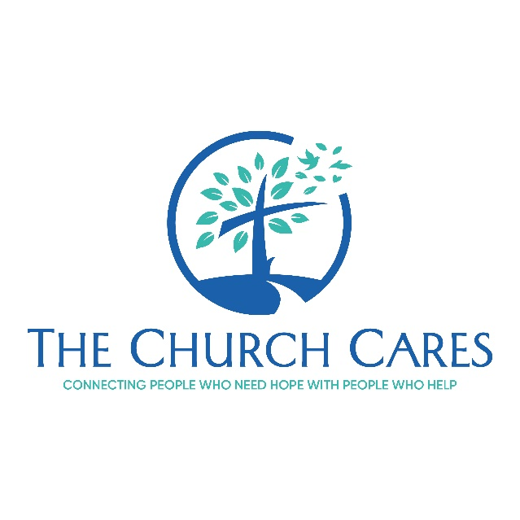

Guidance for Creating your Church Resource Guide and Referral Tool

We recommend that you create a couple of tools for your ministry to assist everyone to access resources when they are needed. While it can be anxiety-producing to consider all of these options, it is best to be well-equipped on resources to respond. Your helper or help-seeker may not need this information for months or years, but when they do need it, they will need it quickly.

- Create an urgent care card. This card would be either physical or digital that helpers can carry in their wallet/ phone to access emergency or urgent care hotlines quickly. You can add local hotlines if available.
Hotlines
988 Mental Health hotline  (U.S.) The National Suicide Prevention Lifeline at 1-800-273-8255  Crisis Text Line (U.S.) Text HOME to 741741  Sexual Assault Hotline (574)-254-7473 | US Veterans Crisis Hotline 1-800-273-TALK(8255)  Center to Prevent Youth Violence 1-866-773-2587  National Runaway Switchboard 1-800-RUNAWAY(786-2929)  SAFE Alternatives for self injurers. selfinjury.com  Al-Anon for family of substance abusers. al-anon.org

- Create a local resource guide for your area. Since this document might change over time if resources change, you might want to have it housed at the front desk of your church or other accessible location for helper or help-seekers to ask when it’s needed. Someone at your church should be tasked with keeping it updated with the following types of recommended local resources:

- Your church pastoral care response procedures. Describe how to access pastoral care and under what circumstances they should contact church pastors/elders/care team for care.
- Local hospitals
- Free/low-cost medical clinics in the area
- Ministries for the homeless or low-income, such as food pantries, assistance with paying bills, etc.
- Mental health providers/practices that you recommend.
- Support groups in your church, or sister churches in your community.
- 12-step groups in your community for substance abuse
- Local Domestic Violence Shelters or Treatment Centers
- Local numbers for reporting child abuse, and your state/ church policy on how to report
- Contact information for church members who are resources for any of these topics and willing to be consulted on issues.

